TWLA ,UN RELATED ANNOUNCEMENT #1

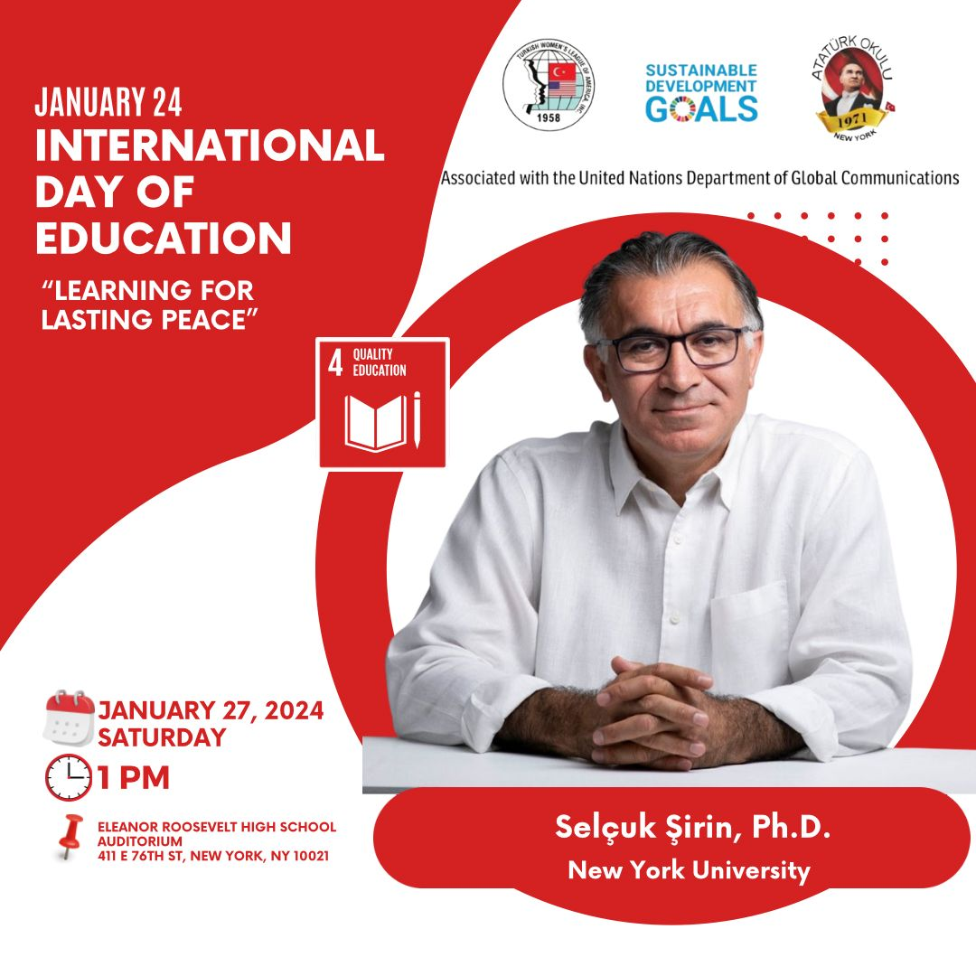
For RSVP: https://forms.gle/1raHUg7wHXsWUsRx9

“The biggest battle is the war against ignorance.” Mustafa Kemal Atatürk

Program Language: English/Turkish

INTERNATIONAL EDUCATION DAY
Education is a human right, a public good and a public responsibility.
The United Nations General Assembly proclaimed 24 January as International Day of Education, in celebration of the role of education for peace and development.
Without inclusive and equitable quality education and lifelong opportunities for all, countries will not succeed in achieving gender equality and breaking the cycle of poverty that is leaving millions of children, youth, and adults behind.
The sixth International Day of Education will be celebrated on 24 January 2024 under the theme “learning for lasting peace”. The world is seeing a surge of violent conflicts paralleled by an alarming rise of discrimination, racism, xenophobia, and hate speech. The impact of this violence transcends any boundary based on geography, gender, race, religion, politics, offline and online.
The focal point of the event is to determine how we could improve the education system to adapt to modern times and prepare for future generations.

PROGRAM

27 JANUARY 2024
INTERNATIONAL DAY OF EDUCATION
TURKISH CENTER

Organized by Turkish Women’s League-America
Associated with the United Nations Department of Global Communications
TIME | SPEAKERS
1:00-2:30 | Welcome President -TWLA Mrs. Berna Gürdal  Our Youth Representative Yasemin Knott (video)  Professor Selçuk Şirin-NY University  Discussion  Refreshment  Moderator: Burçin Rutherford

SPEAKER
Professor SELҪUK ŞİRİN (KEYNOTE SPEAKER)
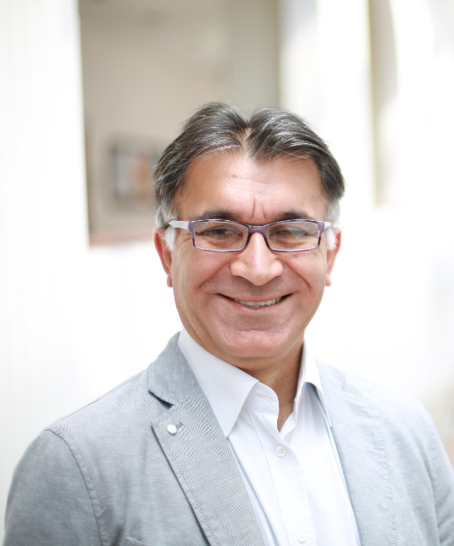
As an applied psychologist, I use empirical research methods to better understand the needs of children and families, and to arm professionals and policy makers with this knowledge to better address the needs of the most vulnerable. The goal that unites all my work is to enhance the lives of marginalized children using development in context as a general framework. I focus on immigrant children in New York, Muslim youth in the US, refugees in Türkiye and Norway, and students at risk in US schools.
I have published my work in top journals, such as Child Development, Developmental Psychology, Review of Educational Research, and Pediatrics, to inform scholars, practitioners, and policy makers about marginalized children. I have also made a concerted effort to get my work to a wider audience both locally and globally, as I believe strongly in “giving scientific knowledge away.” I have served on several policy committees such as the National Academy of Sciences, the Urban Institute, and the Migration Policy Institute. I have collaborated with UNESCO and Save the Children, in their efforts to improve the lives of refugee children.
Since 2019, he is the founder of the 1 Million Books Project, a social enterprise project that aims to instill a love of books in children from birth in Türkiye, to explain the importance of reading and to give the first set of books to children who do not have books at home.

Berna Gürdal (President -TWLA)
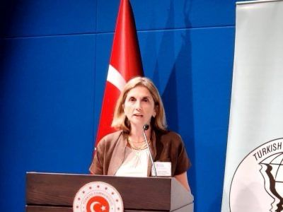
Berna Gürdal graduated from Hacettepe University Department of Nutrition and Dietetics in 1997 and worked as a corporate dietitian at Panorama Food Company between 1997-1999. Between 1998-2005, she worked as a clinical dietitian at Uludağ University, Department of Internal Medicine and made presentations at various congresses. Her studies on diabetes treatment were published in the book Diabetes Mellitus in 2006. Since 2005, Berna Gürdal has been living in New York and received a Certificate in Child Nutrition and Food Program from Stanford University. She is married and has two children. Both of her children graduated from NY ATATURK School. She has been serving on the TWLA Board of Directors since 2017. She has been the TWLA President since 2023.

Yasemin Knott UN Youth Representative
Yasemin Knott is a Junior Social Work major at Siena College in Loudonville, New York. She is a Student Representative on the Siena College Social Work Advisory Board. She is a Community Assistant at Siena College. Through her position as a Community Assistant, she was able to give a successful presentation on the importance of diversity, inclusion, and representation.
Yasemin has been a Turkish Women’s League of America youth representative for the United Nations since January of 2023. Since being inducted into this position, she attended the Assembly of the Turkish American Association’s 2023 Annual Conference.
Yasemin is a 2020 National Honor Society Inductee and a Spanish Honor Society Inductee. She was previously an officer of the Saratoga Springs High School Spanish Culture Club as well as the 2022 Siena College Muslim Student Association Events Coordinator. Yasemin was a cheerleader for 15 years and a dancer for 10 years. She was a Saratoga Springs High School Varsity Competitive Cheerleader and Team Captain for multiple years. She also achieved American Red Cross Certification in Childcare.
Yasemin is learning Turkish, Spanish, and American Sign Language. She attended the Turkish Women’s League of America’s New York Ataturk School and earned a New York Seal of biliteracy in Spanish and English.
Through college courses in high school, she earned credits from Rochester Institute of Technology, Adirondack Community College, and Schenectady City Community College. Yasemin volunteered at Dorothy Nolan Elementary School for 6 years.

NY Atatürk School Teacher -TWLA Board Member Burcin Rutherford-Moderator

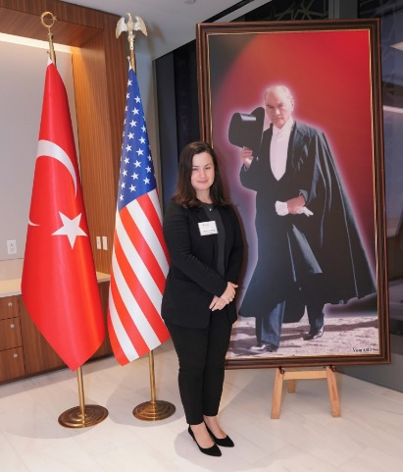

Burcin Rutherford was born in Istanbul, Türkiye. Graduated from Karadeniz Technical University as a Social Studies Teacher. Worked in several pre-schools and Elementary Schools in London where she lived 8 years before moving to NYC. Burcin have been an active member of Turkish American Women’s League since 2021. After joining the board, she has been volunteering at NY Ataturk School to teach Turkish language and culture. She enjoys spending time with her 2 sons, traveling, and discovering new places.

NY ATATÜRK SCHOOL

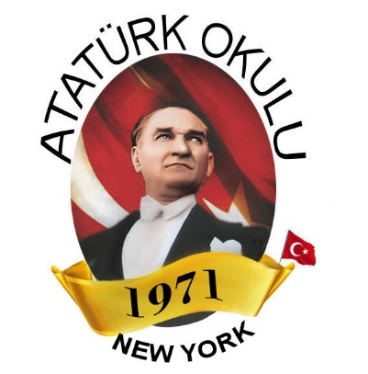

Founded and sponsored by Turkish Women’s League of America (TWLA) since 1971,New York Atatürk School has hundreds of alumni and is the oldest established weekend Turkish educational institution in New York. As a forerunner institution promoting the educational ideals of Atatürk, New York Atatürk School was founded in 1971 with President Ayla Erdamar’s diligent work and endeavor and with the support of Consul General Sait Sahipoğlu. At the time, the classes were held at the Turkish Consulate at Rockefeller Center in New York and the school had only 30 students. With the increase in number of students the following year, the classes were held at the leased classrooms in New York Theological Seminary Building. Between 1974-1977, the education continued at the United Nations International School. With the support of Permanent Representative of Turkey to the United Nations İlter Türkmen and Consul General Sıtkı Coşkun, Atatürk School moved to New York Turkish Center after its acquisition in 1977. During the renovation of the Turkish Consulate Building in New York, Atatürk School continued to provide education by leasing classrooms from public schools in the Manhattan area. Since 2022, we accept students from all the United States and Canada through online and in person education. Our program beginning of October and including the second week of June is implemented for a total of 37 weeks. Every Saturday between 11:00-14:00, education-training, cultural and social activities continue successfully without interruption. Our in person educational address is: Eleanor Roosevelt High School 411 East 76th Street New York 10021.

TURKISH WOMEN LEAGUE OF AMERICA (TWLA)

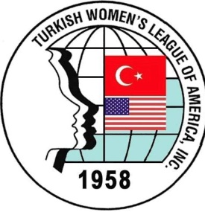

Established on September 17, 1958, as a 501(c)(3) non-profit organization in New York, Turkish Women’s League of America (TWLA) aims to preserve and teach Turkish language and culture to the future generations. The organization is one of the oldest active Turkish American organizations in the USA and is the sole supporter of the NY Atatürk School which has been a pride since 1971. The Turkish Women’s League of America’s Board of Directors is comprised entirely of volunteer members. The organization and its members adhere to the principles of modern Turkey’s founder Mustafa Kemal Atatürk and the values of the Republic and adopt the national, moral, human, spiritual and cultural values of the Turkish Nation. Our Mission is to unite the Turkish women living in America under one roof, to provide solidarity and strength among them. We organize cultural and recreational activities to foster a better understanding between the people of Turkey and the United States. With this awareness, Turkish Women’s League of America works devotedly with institutions and nongovernmental organization to achieve and preserve the deserved respected place of women in the society.
The Turkish Women’s League of America is proud to announce our association with the United Nations Department of Global Communications as of December 10,2021.

